Exercise 7 (Daily Expense Tracker)

* **Definition:**

You have to create one Desktop Application which can track your Daily Expense Details and generate the reports based on it,

You have to use WPF from for Developing this Application. And for storing the information you have to use SQL Server Database.

* **Requirements:**
* Your System Contain the Authentication.
* You can use the previous exercise Login screen if you don’t want to create a new Login and Registration screen.
* System should handle the multiple use information like every user detail are separated and based on ID user can be identify.
* User Can enter the Daily Expense into the system for that you have to use relative UI Control like select today Date you have to put DateTimePicker control into DailyExpensePage.
* For Expense Details you have to create one Combobox which contain the Expense Names like Vegetable, Movie, Petrol, House Rent etc. so User can easily select the Expense.
* You have to also give on Textbox for other like the some expense not happen in daily bases so your Combobox not contain it in that case user can add manually.
* Below mentioned image show you how you have to put the UI control in your home page of Daily Expense Tracker.
* Amount is the price of the goods
* Remarks are optional infos
* 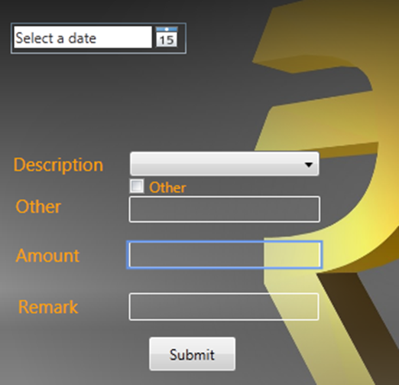
* IN THIS SAME PAGE YOU WILL ADD A SECOND BUTTON named Reports&ViewData, when you press that button one new window will pop up.
* Reports&ViewData Window contain the two buttons Generate Report and View Data.
* When you press Generate report you have to create an Excel File which contains the below mentioned fields in Excel.
* Date
* Item
* Amount
* Remark
* You have to calculate Total Amount and show it on Right side of Excel.
* When View Data Press then all the Expense Details should be display in Datagrid.
* 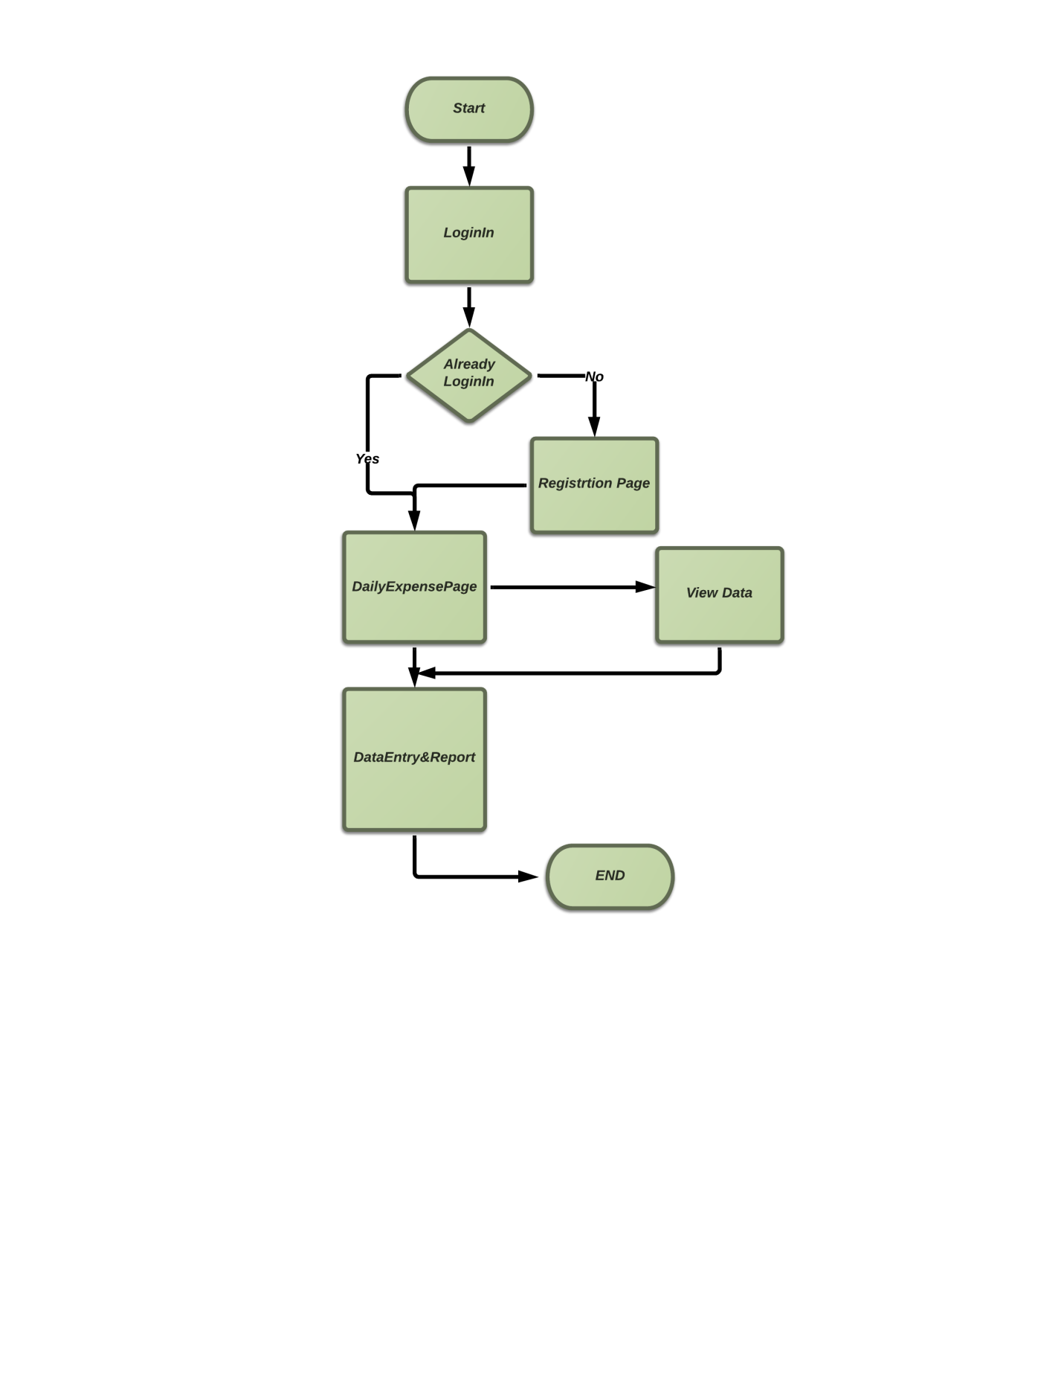**Flow of the Application:**